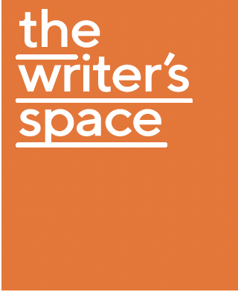
The Writer’s Space – Online Fellowship
2022 PROGRAM SCHEDULE

Welcome and meet and greet with Amy Sambrooke, Creative Director - Varuna, Vanessa Kirkpatrick, Senior Programs Officer, Rebecca Goosen, Strategic Initiatives Officer
Monday 5 September: 12 noon – 1 pm

Access to Wet Ink and a selected ‘VARUNA ON DEMAND’ course
Monday 5 September – Friday 30 September

Writers Conversations with Dr Carol Major – via Zoom*
Book in two Writers Conversations during the month of September

Daily writing sessions on Zoom
Monday – Friday 11am – 12 noon
‘Shut up and write’ sessions

Group introductions and Publishing Q & A session with Julia Carlomagno from Monash University Publishing.
Thursday 8 September 12 noon – 1.30pm

Webinar and Q&A: NDIS and the Arts* *Optional session
Thursday 15 September 12 – 1pm

Facilitated Reading Session
Friday 16 September 12 noon – 1pm

Facilitated Reading Session
Thursday 22 September 12 noon – 1pm

Facilitated Reading Session
Thursday 29 September 12 noon – 1pm

Final debrief session
Friday 30 September 12 noon – 1pm
Fellowship wrap-up and debrief via zoom with Amy Sambrooke, Creative Director – Varuna and Vanessa Kirkpatrick, Senior Programs Officer, Rebecca Goosen, Strategic Initiatives Officer

Social catch up: Please note that in addition to these the core scheduled sessions listed, participants may organise to meet with each other on Zoom to further discuss their work, or join each other for group writing sessions.

