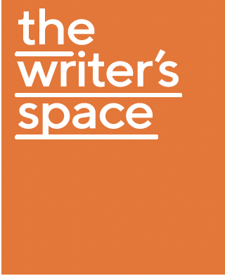
The Writer’s Space - Residency Fellowship
2022 PROGRAM SCHEDULE

Welcome and meet and greet with Veechi Stuart, Executive Director or Amy Sambrooke, Creative Director - Varuna
Monday 5 September: 4pm – 5pm

Writer Conversations with Dr Carol Major
Two Writer Conversations are included in the fellowship. Book in a session during the week of 5 September and a follow up in the month after the residency.

Daily writing sessions on zoom
Monday – Friday 11am – 12noon
‘Shut up and write’ sessions

Access to a selected ‘VARUNA ON DEMAND’ course
Can be accessed at any time during the month of September

Reading session 1
Wednesday 7 September: 4pm – 5pm

Group introductions and Publishing Q & A session with Julia Carlomagno from Monash University Publishing.
Thursday 8 September 12 noon - 1.30pm

Reading session 2
Thursday 8 September: 4pm – 5pm

Reading session 3
Friday 9 September: 4pm – 5pm

Final dinner
Sunday 11 September 6pm
Fellowship wrap-up and debrief over dinner at The Lookout Katoomba

Webinar and Q &A: NDIS and the Arts* *Optional session
Thursday 15 September 12-1pm

